|  |  |  |
| --- | --- | --- |
| **S.NO** | **TOPIC** | **PAGE NO.** |
| **1.** | TITLE |  |
| **2.** | INDEX |  |
| **3.** | INTERNSHIP LETTER |  |
| **4.** | DECLERATION |  |
| **5.** | ACKNOWLEDGEMENT |  |
| **6.** | ABOUT TRAINING |  |
| **7.** | ABOUT UNICLOUD |  |
| **8.** | OBJECTIVES |  |
| **9.** | DATA SCIENCE |  |
| **10.** | MY LEARNINGS |  |
| **11.** | REASON FOR CHOOSING DATA SCIENCE |  |
| **12.** | LEARNING OUTCOMES |  |
| **13.** | SCOPE IN DATA SCIENCE |  |
| **14.** | RESULTS |  |

**INDEX**

**INTERNSHIP LETTER**

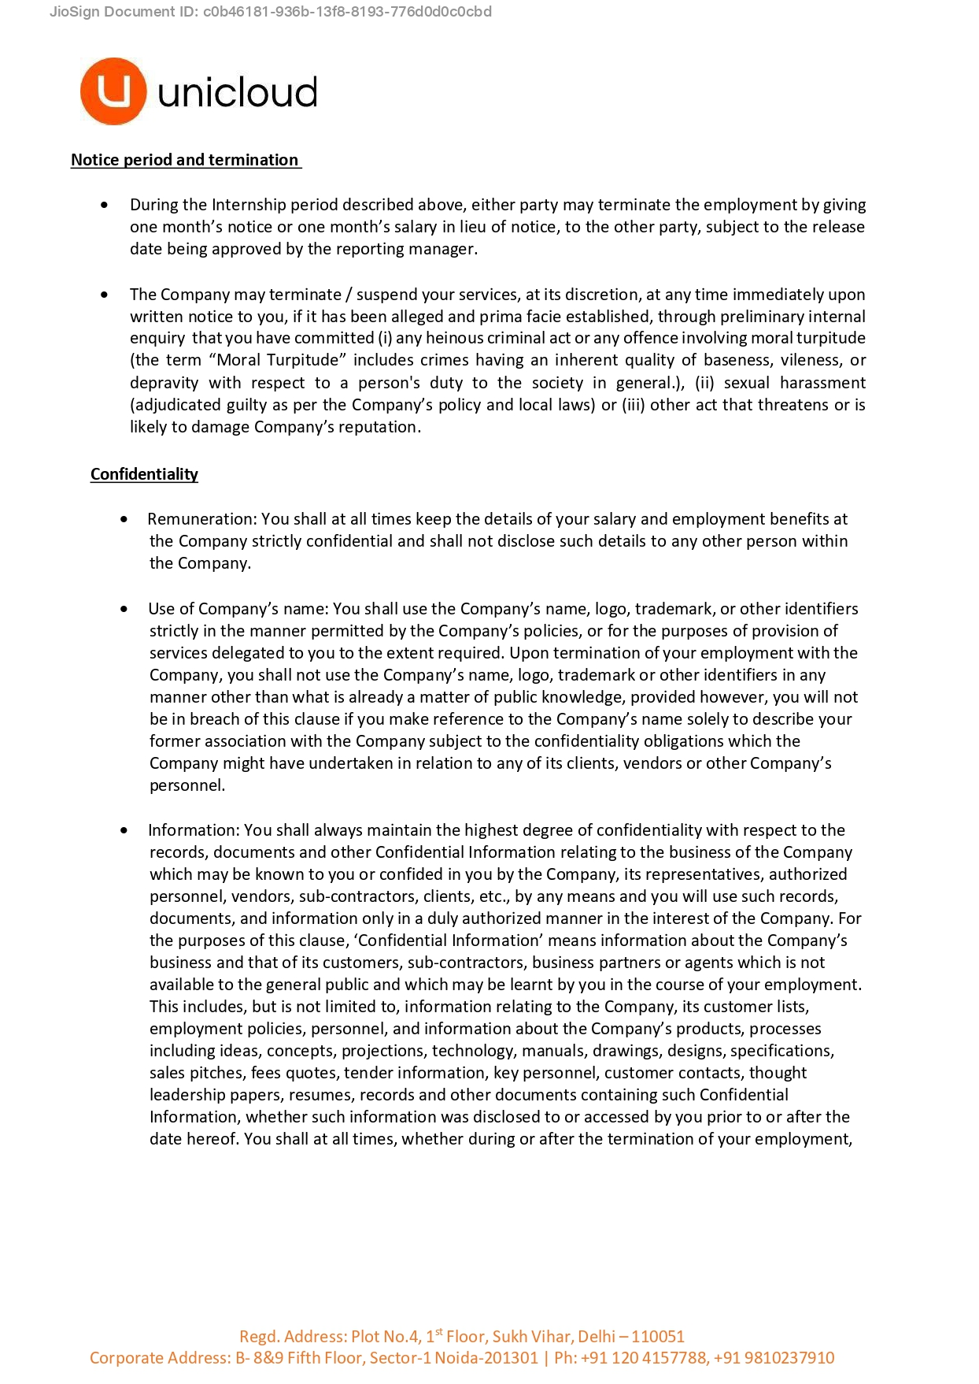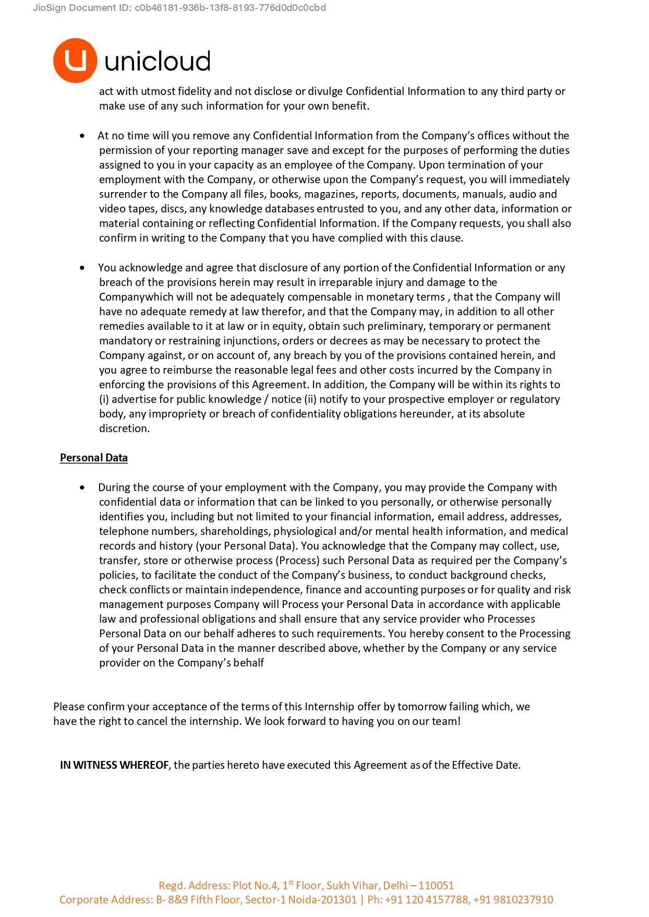

**DECLARATION**

I, Nishant Goel, solemnly declare that the information provided in this internship report is true, accurate, and reflective of my internship experience at UNICLOUD.

I affirm that the projects, tasks, and responsibilities outlined in this report accurately represent my contributions and experiences during the internship period. Any references or citations included in this report are duly acknowledged and attributed to their respective sources.

Furthermore, I declare that this internship report is the result of my own work and efforts, with appropriate guidance and supervision from my internship supervisor at UNICLOUD.

I understand that any misrepresentation or falsification of information in this report may have serious consequences, including academic penalties and damage to my reputation.

By signing this declaration, I affirm my commitment to academic integrity and honesty in all aspects of my academic and professional endeavors.

# Date: __________

# Signature: __________

**ACKNOWLEDGEMENT**

I take this opportunity to express my sincere thanks and deep gratitude to all those people who extended their wholehearted cooperation and have helped me in completing this internship successfully.

First, I would like to thank our supervisor Mr. Prakash Chandra Saraswat, who mentored me, guided me and challenged me.

I also thank my family and friends who greatly supported me during the Internship.

Last but not the least, I would like to thank our founders for considering me a part of the organization and provide such a great Platform to learn and enhance my skills.



A very special thanks goes to all the faculties of Gautam Buddha University, Greater Noida under whom guidance I have been able to excel in my career and become a part of the Watchguard family.

Nishant Goel

235PMD001

Gautam Buddha University, Greater Noida

**ABOUT COMPANY**

Unicloud is one of the fastest growing Cloud & AI Consulting company, we strive to help our customers maximize returns on their cloud investments. We provide platform and expertise across the cloud lifecycle starting with Assessment, Migrations, Deployment, Optimization and SRE. In last few years we have helped over 100 enterprises realize $ 44Mn+ in cloud savings.

**Why choose UNICLOUD?**

1. Cloud-Native Infrastructure – Scalable and flexible cloud environment for handling large datasets and machine learning workloads.
2. AI & Data Science Integration – Built-in AI tools, automated ML training, and real-time data analytics support.
3. Cost-Effective Solutions – Competitive pricing compared to AWS, Azure, and Google Cloud, making it ideal for startups and researchers.
4. Security & Compliance – Strong security framework with compliance support (e.g., GDPR, HIPAA) for safe data storage and processing.
5. Developer-Friendly Tools – Easy-to-use APIs, SDKs, and managed environments for deploying ML models without deep infrastructure expertise.
6. Industry-Specific Solutions – Tailored cloud services for sectors like finance, healthcare, and IoT, offering optimized performance.
7. Collaboration & Community Support – Active developer community, detailed documentation, and training programs for easy adoption.

**Internship Objectives**

The objective of this internship was to gain practical experience in data science within a cloud-based environment. My primary focus areas included:

* Understanding cloud-based data processing and storage.
* Working with large datasets hosted on cloud platforms.
* Applying machine learning algorithms to real-world problems.
* Collaborating with cross-functional teams to extract meaningful insights from data.

**Roles and Responsibilities**

During my internship, I was assigned the following key responsibilities:

1. **Data Preprocessing & Cleaning** – Extracting, cleaning, and preprocessing raw data stored on cloud databases.
2. **Exploratory Data Analysis (EDA)** – Performing statistical and visual analysis to understand data trends.
3. **Machine Learning Implementation** – Developing predictive models using Python and cloud-based ML services (e.g., AWS SageMaker, Google Vertex AI, or Azure ML).
4. **Data Visualization** – Creating dashboards and reports using tools like Power BI, Tableau, and Matplotlib.
5. **Cloud Integration** – Deploying data pipelines and models on cloud platforms such as AWS, Google Cloud, or Azure.
6. **Collaboration & Documentation** – Working with data engineers, software developers, and business analysts to ensure data-driven decision-making.

**What is Data Science?**

Data Science as a multi-disciplinary subject that uses mathematics, statistics, and computer science to study and evaluate data. The key objective of Data Science is to extract valuable information for use in strategic decision making, product development, trend analysis, and forecasting. Data Science concepts and processes are mostly derived from data engineering, statistics, programming, social engineering, data warehousing, machine learning, and natural language processing. The key techniques in use are data mining, big data analysis, data extraction and data retrieval.

Data science is the field of study that combines domain expertise, programming skills, and knowledge of mathematics and statistics to extract meaningful insights from data. Data science practitioners apply machine learning algorithms to numbers, text, images, video, audio, and more to produce artificial intelligence (AI) systems to perform tasks that ordinarily require human intelligence. In turn, these systems generate insights which analysts and business users can translate into tangible business value.

**DATA SCIENCE PROCESS:**

1. The first step of this process is setting a research goal. The main purpose here is making

sure all the stakeholders understand the what, how, and why of the project.

2. The second phase is data retrieval. You want to have data available for analysis, so this

step includes finding suitable data and getting access to the data from the data owner. The

result is data in its raw form, which probably needs polishing and transformation before

it becomes usable.

3. Now that you have the raw data, it’s time to prepare it. This includes transforming the

data from a raw form into data that’s directly usable in your models. To achieve this,

you’ll detect and correct different kinds of errors in the data, combine data from different

data sources, and transform it. If you have successfully completed this step, you can

progress to data visualization and modelling.

4. The fourth step is data exploration. The goal of this step is to gain a deep understanding

of the data. You’ll look for patterns, correlations, and deviations based on visual and

descriptive techniques. The insights you gain from this phase will enable you to start

modelling.

5. Finally, we get to the sexiest part: model building (often referred to as “data modelling”

throughout this book). It is now that you attempt to gain the insights or make the

predictions stated in your project charter. Now is the time to bring out the heavy guns,

but remember research has taught us that often (but not always) a combination of simple

models tends to outperform one complicated model. If you’ve done this phase right,

you’re almost done.

6. The last step of the data science model is presenting your results and automating the

analysis, if needed. One goal of a project is to change a process and/or make better

decisions. You may still need to convince the business that your findings will indeed

change the business process as expected. This is where you can shine in your influencer

role. The importance of this step is more apparent in projects on a strategic and tactical

level. Certain projects require you to perform the business process over and over again,

so automating the project will save time.

**MY LEARNING**

**1) INTRODUCTION TO DATA SCIENCE**

• Overview & Terminologies in Data Science

• Applications of Data Science

➢ Unfamiliar detection (fraud, disease, etc.)

➢ Automation and decision-making (credit worthiness, etc.)

➢ Classifications (classifying emails as “important” or “junk”)

➢ Forecasting (sales, revenue, etc.)

➢ Pattern detection (weather patterns, financial market patterns, etc.)

➢ Recognition (facial, voice, text, etc.)

➢ Recommendations (based on learned preferences, recommendation engines can

refer you to movies, restaurants and books you may like)

**2) PYTHON FOR DATA SCIENCE**

Introduction to Python, Understanding Operators, Variables and Data Types, Conditional Statements, Looping Constructs, Functions, Data Structure, Lists, Dictionaries, Understanding Standard Libraries in Python, reading a CSV File in Python, Data Frames and basic operations with Data Frames, Indexing Data Frame.

**3) UNDERSTANDING THE STATISTICS FOR DATA SCIENCE**

Introduction to Statistics, Measures of Central Tendency, Understanding the spread of data,

Data Distribution, Introduction to Probability, Probabilities of Discrete and Continuous

Variables, Normal Distribution, Introduction to Inferential Statistics, Understanding the

Confidence Interval and margin of error, Hypothesis Testing, Various Tests, Correlation.

**4) PREDICTIVE MODELING AND BASICS OF MACHINE LEARNING**

Introduction to Predictive Modelling, Types and Stages of Predictive Models, Hypothesis Generation, Data Extraction and Exploration, Variable Identification, Univariate Analysis for Continuous Variables and Categorical Variables, Bivariate Analysis, Treating Missing Values and Outliers, Transforming the Variables, Basics of Model Building, Linear and Logistic Regression, Decision Trees, K-means Algorithms in Python.

Summary of Procedure of Analysing Data:

Data science generally has a five-stage life cycle that consists of:

• Capture: data entry, signal reception, data extraction

• Maintain: Data cleansing, data staging, data processing.

• Process: Data mining, clustering/classification, data modelling

• Communicate: Data reporting, data visualization

• Analyse: Predictive analysis, regression

**Introduction to Data Science**

**Data Science**

The field of bringing insights from data using scientific techniques is called data science.

**Applications**

Amazon Go – No checkout lines

Computer Vision - The advancement in recognizing an image by a computer involves processing large sets of image data from multiple objects of same category. For example, Face recognition.

**Reporting / Management Information System**   
To track what is happening in organization.   
**Detective Analysis**   
Asking questions based on data we are seeing, like. Why something happened?   
**Dashboard / Business Intelligence**   
Utopia of reporting. Every action about business is reflected in front of screen.   
**Predictive Modelling**   
Using past data to predict what is happening at granular level. Big Data  
Stage where complexity of handling data gets beyond the traditional system.   
Can be caused because of volume, variety or velocity of data. Use specific tools to analyse such scale data.

**Application of Data Science**

**• Recommendation System**

Example-In Amazon recommendations are different for different users according to their past search.

**• Social Media**   
1. Recommendation Engine   
2. Ad placement   
3. Sentiment Analysis   
**• Deciding the right credit limit for credit card customers.   
• Suggesting right products from e-commerce companies**   
1. Recommendation System   
2. Past Data Searched   
3. Discount Price Optimization   
**• How google and other search engines know what are the more relevant results for our search query?**   
1. Apply ML and Data Science   
2. Fraud Detection   
3. AD placement   
4. Personalized search results

**What is Python?**

Python is an interpreted, high-level, general-purpose programming language. It has efficient high-level data structures and a simple but effective approach to object-oriented programming. Python’s elegant syntax and dynamic typing, together with its interpreted nature, make it an ideal language for scripting and rapid application development in many areas on most platforms.

**Python for Data science:**

**Why Python???**

1. Python is an open source language.

2. Syntax as simple as English.

3. Very large and Collaborative developer community.

4. Extensive Packages.

**• UNDERSTANDING OPERATORS:**

Theory of operators: - Operators are symbolic representation of Mathematical tasks.

• **VARIABLES AND DATATYPES:**

Variables are named bounded

d to objects. Data types in python are int (Integer), Float, Boolean and

strings.

• **CONDITIONAL STATEMENTS:**

If-else statements (Single condition)

If- Elif- else statements (Multiple Condition)

• **LOOPING CONSTRUCTS:**

For loop

• **FUNCTIONS:**

Functions are re-usable piece of code. Created for solving specific problem.

Two types: Built-in functions and User- defined functions.

Functions cannot be reused in python.

• **DATA STRUCTURES:**

Two types of Data structures:

LISTS: A list is an ordered data structure with elements separated by comma and enclosed within square brackets.

DICTIONARY: A dictionary is an unordered data structure with elements separated by comma and stored as key: value pair, enclosed with curly braces {}.

**Statistics**

**Descriptive Statistic**

**Mode**

It is a number which occurs most frequently in the data series.

It is robust and is not generally affected much by addition of couple of new values.

**Code :**

import pandas as pd

data=pd.read_csv( "Mode.csv") //reads data from csv file

data.head() //print first five lines

mode_data=data['Subject'].mode() //to take mode of subject column

print(mode_data)

**Mean**

import pandas as pd

data=pd.read_csv( "mean.csv") //reads data from csv file

data.head() //print first five lines

mean_data=data[Overallmarks].mean() //to take mode of subject column

print(mean_data)

**Median**

Absolute central value of data set.

import pandas as pd

data=pd.read_csv( "data.csv") //reads data from csv file

data.head() //print first five lines

median_data=data[Overallmarks].median() //to take mode of subject column

print(median_data)

Types of variables

• Continous – Which takes continuous numeric values. Eg-marks

• Categorial-Which have discrete values. Eg- Gender

• Ordinal – Ordered categorial variables. Eg- Teacher feedback

• Nominal – Unorderd categorial variable. Eg- Gender

**Algorithm for Machine Learning**

Machine learning algorithms can be categorized into different types based on their learning approach. Here are some key algorithms:

**Supervised Learning Algorithms**

(Uses labeled data for training)

1. Linear Regression – Used for predicting continuous values (e.g., house price prediction).
2. Logistic Regression – Used for classification problems (e.g., spam detection).
3. Decision Trees – Uses tree-like structures for decision-making.
4. Random Forest – An ensemble of decision trees for better accuracy.
5. Support Vector Machine (SVM) – Finds the optimal boundary for classification tasks.
6. K-Nearest Neighbours (KNN) – Classifies data based on the closest neighbours.
7. Neural Networks (ANN, CNN, RNN) – Used in deep learning applications like image recognition and NLP.

**Unsupervised Learning Algorithms**

(Finds patterns in unlabelled data)

1. K-Means Clustering – Groups similar data points into clusters.
2. Hierarchical Clustering – Creates a tree-like cluster structure.
3. Principal Component Analysis (PCA) – Reduces dimensionality of data.
4. Autoencoders – Used in deep learning for data compression and feature extraction.

**Reinforcement Learning Algorithms**

(Learns by interacting with an environment)

1. Q-Learning – Uses a Q-table to learn optimal policies.
2. Deep Q-Network (DQN) – Combines Q-learning with deep learning.
3. Policy Gradient Methods – Learns policies directly using gradient ascent.

**Conclusion**

My internship at UNICLOUD has been a transformative learning experience. It provided me with an in-depth understanding of data science applications in cloud environments. The hands-on experience with cloud computing, data pipelines, and machine learning models has enhanced my technical and professional skills. I am grateful for this opportunity and look forward to applying my learnings in future endeavours.

**Signature:**  
Nishant Goel  
**Date:** 05-03-2025